Sampling Theory ~(contimnue)

Example 1 : Consider a population with 5 units having value 1,5,7,9,13. Obtain all possible samples of size “2” drawn by:

1) Simple random sampling with replacement (srswr)

2) Simple random sampling without replacement (srswor)

1→ (1,1),(1,5),(1,7),(1,9),(1,13),(5,1),(5,5),…….,(7,1),(7,5),……,(13,13)

2→ (1,5),(1,7),(1,9),(1,13),(5,7),(5,9),(5,13),(7,9),(7,13),(9,13)

Example 2 : For a population with 5 units having value 1,5,7,9,13. Calculate population mean(µ) and varience (σ2). Consider all samples of size “2” drawn by srswr , calculate the different possible sample means() and prove that E(x’) = µ and V(x’) = σ2/n

→ here popn mean(µ) = (1+5+7+9+13)/5 = 7

popn variance(sigma2) = (1/n)Σ(x-µ)2 = 16

the means of 25 possible samples drawn by srswr are(obtained by previous ans):

1,3,4,5,7,3,5,6,7,9,4,6,7,8,10,5,7,8,9,11,7,9,10,11,13

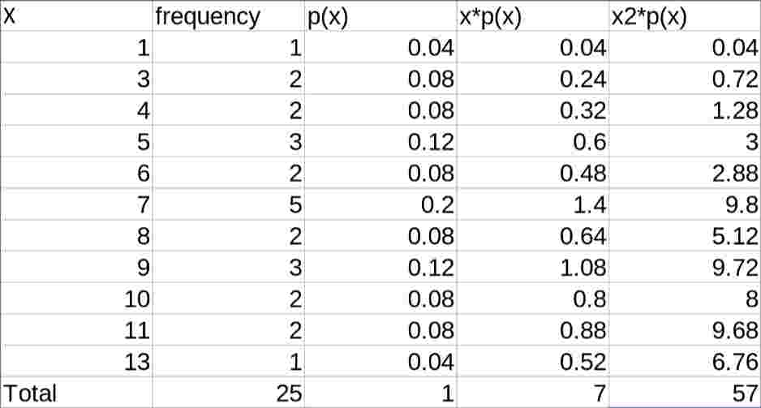

(all the “x” above diagram are x’)

Now,

E(X) = Σx’\*p(x) = 7 = µ

v(X) = E(x’2)-(E(x’))2

= Σx’2\*p(x’) - 72

= 57-49

= 8 = 16/2 = σ2 / n

therefore:

E(x’) = µ

V(x’) = σ2 /n

So,

(x’-µ)/ ~ N(0,1)

(x’-µ=)/ σ2 /n ~ N(0,1)

If σ2 is popn varience then sample varience is

s2 = (1/n) Σ(x-x’)2

It can be shown that:

E(s2) = (n-1)/n \* σ2

E(s2) != σ2

However using

E(s2) = (n-1)/n \* σ2

we get,

n/(n-1) E(s2) = σ2

= E(n/(n-1)s2) = σ2

= E(S2) = σ2

where,

S2 = 1/(n-1)Σ (x - x’)2